SOFTWARE ENGINEERING LAB
Experiment No. 4: Project-Based Data Flow Diagram (DFD)
Use your own selected software project
Name | ________________________ | Roll No. | ________________________
Class/Section | ________________________ | Date | ________________________

1. Aim
To prepare a Context Diagram, Level 0 DFD and one Level 1 DFD for your own software project.

2. Important Instruction
This Lab 4 must be connected with your own project. Do not copy the Library Management System diagram unless Library Management System is actually your project. The Library example used in class is only to understand the method.

3. Your Project Details
Project Title | kvstore – Distributed Key-Value Store with AI-Powered Observability
One-line purpose of the project | A distributed, strongly-consistent key-value store that replicates data using Raft consensus and uses an AI assistant to detect anomalies and suggest root causes to operators.
Main users/external systems | Client Application; Cluster Operator; External LLM Provider
Three to six major functions | API & Routing; Consensus (Raft); Storage (WAL, MVCC); Observability (Metrics + AI Assistant)
Earlier project document used (requirements/use case, if available) | kvstore Architecture Document & draw.io DFD design (KV_Store_data_flow_level_wise_V2)

4. Before Drawing the DFD
Look at your project requirements/use cases. Write only the items that really belong to your project.
S. No. | External Entity | Data sent to system | Data received from system
1 | Client Application | KV Requests (reads / writes) | Txn Outcomes / Data
2 | Cluster Operator | (monitoring only) | Live Dashboard (Alerts / Insights)
3 | External LLM Provider | Root Cause Hypotheses | Anomaly Evidence
4
5

5. Major Processes of Your Project
Write 3–6 major functions as processes. Use action words, for example: Manage Orders, Record Attendance, Generate Report.
Process No. | Process Name | What does this process do?
1.0 | API & Routing | Handles client HTTP/gRPC transport, request routing and shard lookup (sub-modules: httpapi/transport, client, shard).
2.0 | Consensus | Implements Raft-based distributed consensus: leader election, log replication and write-ahead logging of proposals.
3.0 | Storage | Persists committed log entries; manages the hybrid logical clock (HLC) and multi-version concurrency control (MVCC).
4.0 | Observability | Collects performance metrics and feeds an AI module that raises alerts, insights and root-cause hypotheses.
5.0
6.0

6. Data Stores
Write the important places where your project stores data.
Data Store | Name | What data is stored?
D1 | Persistent Storage | Committed KV entries, write-ahead log (WAL) records and MVCC versioned data, fsync-appended to disk.
D2
D3
D4

7. Context Diagram
Draw the whole project as ONE process. Show the main external entities and major input/output data. Do not show internal processes or data stores here.
Paste/screenshot your Context Diagram below:
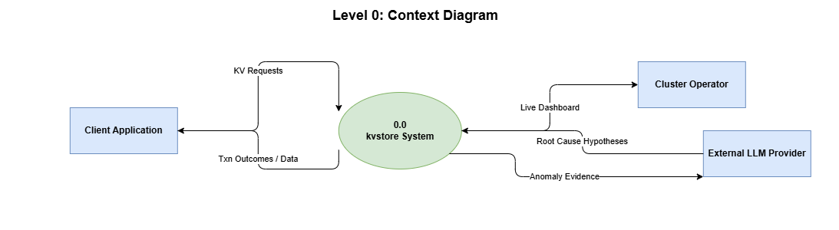
Check: Does the process contain your own project name? ☑ Yes / ☐ No

8. Level 0 DFD
Break your project into its major processes. Add required data stores and connect everything using labelled data arrows.
Paste/screenshot your Level 0 DFD below:
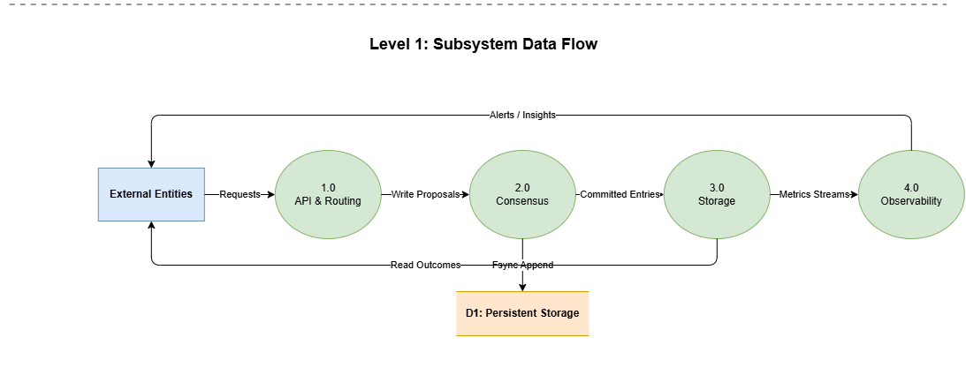

9. Level 1 DFD
Choose ONE process from your Level 0 DFD and break it into smaller steps.
Selected Level 0 Process | 2.0 Consensus
Why did you select it? | Consensus is the most critical and complex subsystem — it guarantees strong consistency across the cluster. (For context, the diagram also shows the internal packages of 1.0 API & Routing, 3.0 Storage and 4.0 Observability, since they interact directly with Consensus.)
Smaller sub-processes | 2.1 raft (Raft algorithm — leader election, log replication); 2.2 wal (Write-Ahead Log — durability of proposals before commit)
Paste/screenshot your Level 1 DFD below:
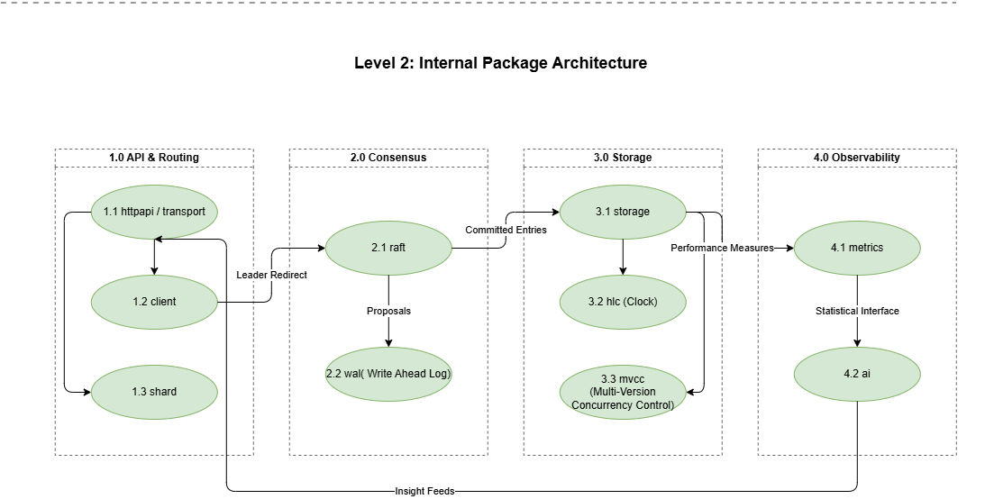

10. Balancing Check
Check that the same important input/output data is represented consistently when you move from one DFD level to the next.
Check | Yes/No | Correction made, if any
Context Diagram and Level 0 are consistent. | Yes | None
Selected Level 0 process and Level 1 are consistent. | Yes | None
No unrelated data suddenly appears in Level 1. | Yes | None

11. Final Review
☑ The work is based on my own project.
☑ Process names match my project requirements/functions.
☑ Arrows show data, not actions/control flow.
☑ Every important arrow has a clear data label.
☑ External entities are not directly connected to data stores.
☑ Context, Level 0 and Level 1 are easy to read.
☑ I can explain the diagram in simple words.

12. Result
Write 2–3 simple lines.

The kvstore project was modeled successfully across three DFD levels. The Context Diagram shows the system boundary with the Client Application, Cluster Operator and External LLM Provider. The Level 0 DFD decomposes the system into four major processes (API & Routing, Consensus, Storage, Observability) connected through one persistent data store, and the Level 1 DFD expands the Consensus process into its concrete internal modules (raft, wal), confirming that data flows stay consistent across all levels.

